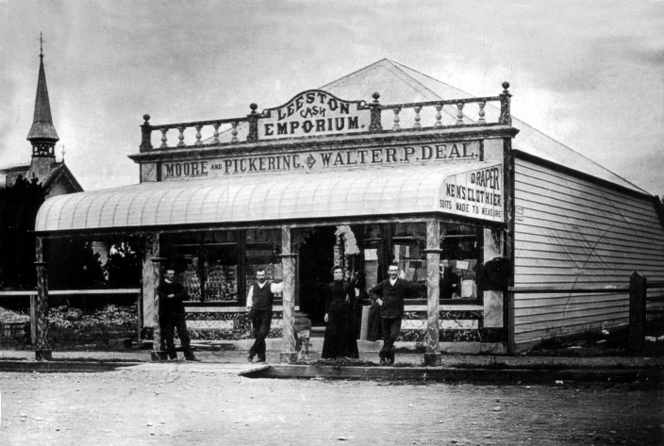
and
Frieda Looser History Ltd
History in Our Countryside:

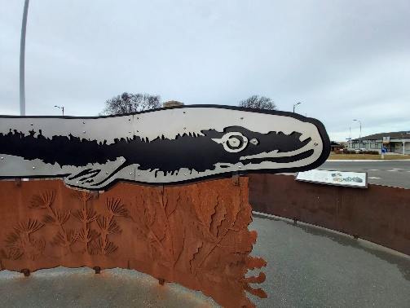
St Mary’s Church, Irwell; Leeston township and the Eel Project; St John’s Church, Leeston; Selwyn Heritage Centre; drive via Waihora Lake Ellesmere and Taumutu

Full day history bus tour
departing from the
University of Canterbury, Ilam

Sunday 27 September 2026
9.30 am – 5 pm

$65 per person including transport/koha (lunch not included)

Frieda Looser History Ltd
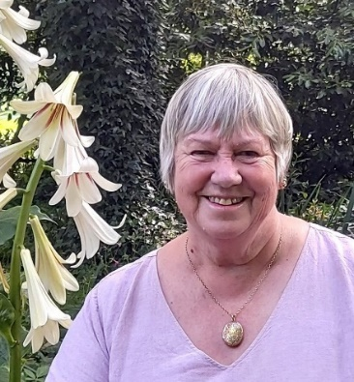
Frieda Looser is a member of the Canterbury History Foundation Executive Committee and the Director and Lecturer of Frieda Looser History Ltd, established in 2012.

To enrol:
Please email Frieda Looser at frieda.looser@gmail.com

including names of participants and contact mobile phone number

Complete enrolment by online banking:
The account is Frieda Looser History Ltd
02 0874 0275670-00

Please put in your surname and initial, and Bus Tour as a reference

As an alternative to personal online banking, a bank teller at any branch of BNZ will make the payment into this account for you at no charge.

A receipt, confirmation of enrolment, and further details will be sent to your email address

